01-04-2024

First Create the New VPC , subnet , Route Table , NAT gate and Login to the AWS Console .

**Assignment**

I want to use any of your VPC where you have your Public & Private Subnets

(If it is not create one)

Launch a Windows EC2 in your public Subnet with public IP

Launch a Linux EC2 in your private Subnet with your Public IP

Connect Windows Machine from your Laptop

------------------------------------------------------------------------------------------------------------------------------------

Go inside your Windows OS and try to connect your LInux Machine with Public IP >>>> Is it connecting ???? NO

Then try to connect with your Linux Machin with PRivate IP >>>> Is it connecting???? NO

My VPC

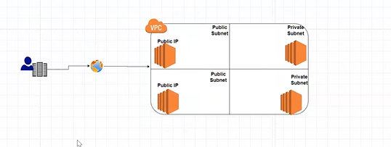

Route Table

Internet Gateway

Now create the

Launch a Windows EC2 in your public Subnet with public IP

Default Security Group

Copy Mobaxterm and windows key pair from Mumbai Region in Win EC2 Instance

And install the mobaxterm to connect the EC2 machine in private subnet

Now Install the EC2 Linux machine in Private subnet

Go inside your Windows OS and try to connect your LInux Machine with Public IP >>>> Is it connecting ???? No

Copy Private IP from Linux Machine

Paste in mobaxterm

NO

NATgate will give the internet to private subnet

We are doing this activity because your private subnet become a remain private and secure .

Because this Nat gateway is one way .

Internet can access the private subnet but private subnet can not access the Internet dute to NAT Gateway.

Internet gateway is free

NAT gateway is Chargeable =0.004 USD/per hrs

Internet gateway is two want and Nat gateway in one way.

Elastic IP is there we have to pay to AWS .

>>> When you create a NAT GW one EIP will be created Automatically that is the reason for NAT GW is chargeable

>>> When you delete your NAT GW, EIP is not automatically Deleting, you have to delete it Manually ????

LAB to be done

NAT Agateway

Go to the NAT >>> Create NAT gateway

Give your NAT GW Name

Choose your Any Public Subnet

Connectivity type >>> Public

Allocate EIP

Create NAT gateway

Once it is Available

Go to the Private RT

Go to the Routes from the Bottom

Edit Routes

Add Route >>>>

Destination >> 0.0.0.0/0

Target >>> NAT >>> Choose your NAT GW >>> Click/check Twice it is selected or not

Save Changes

Go inside your Windows OS and try to connect your LInux Machine with Public IP >>>> Is it connecting ???? --yes its connecting Now

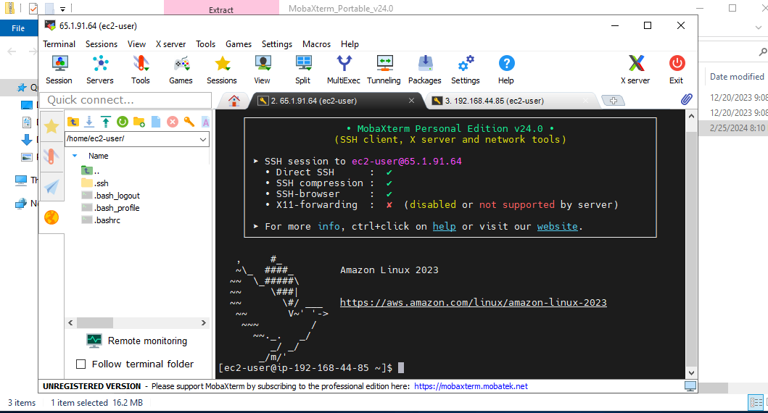

Then try to connect with your Linux Machin with PRivate IP >>>> Is it connecting ????

Yes its connecting now

We have successful done Hands on on NAT gate for connecting EC2 Linux Machine by Public and Private subnets

To Delete the Elastic IP we need to delete the EC2 Instances associated , NAT Gateway , etc and then delete the Elastic IP

Pls check and update hands on for 30th March Conducted by Mahesh Babu Sir on our Saturday Live Sessions .

Thanks

Mahesh Zade